Test Case: tc005_SPX_Dev5_Validacion_Filtro_Campo_URLPath_Administrador_Menu
Step 1 - Enter username and password and click to button Enter : Credentials Entered
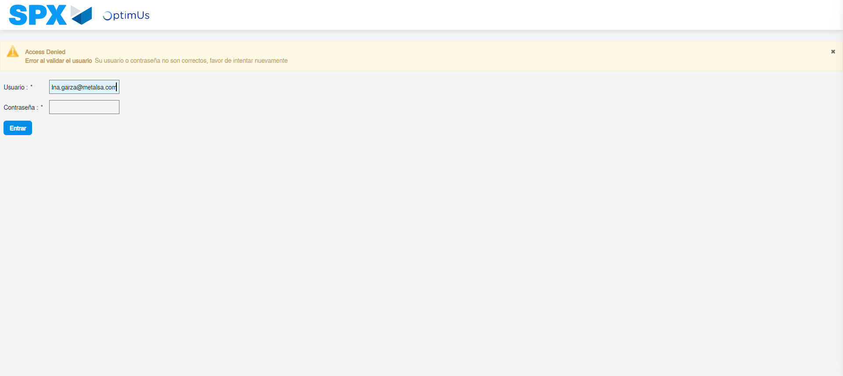Image file-name: QC_Testing-tc005_SPX_Dev5_Validacion_Filtro_Campo_URLPath_Administrador_Menu-may. 15 2024, 01 01 21 p. m.

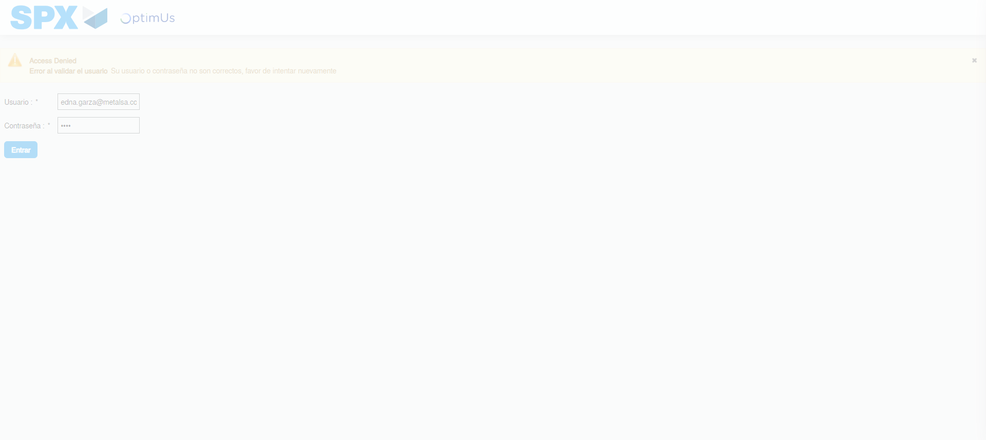Image file-name: QC_Testing-tc005_SPX_Dev5_Validacion_Filtro_Campo_URLPath_Administrador_Menu-may. 15 2024, 01 01 22 p. m.

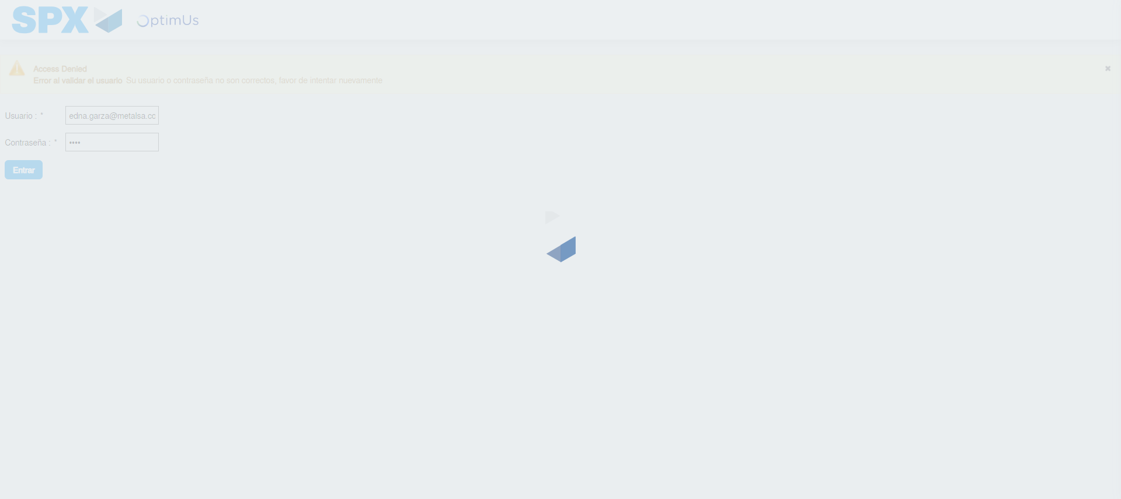Image file-name: QC_Testing-tc005_SPX_Dev5_Validacion_Filtro_Campo_URLPath_Administrador_Menu-may. 15 2024, 01 01 23 p. m.

Step 2 - Select to UEN and Access to Administrador Roles Menu: UEN Correctly selected and Correct access
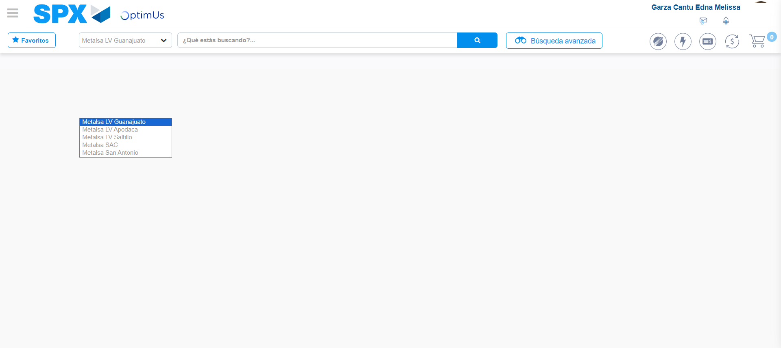Image file-name: QC_Testing-tc005_SPX_Dev5_Validacion_Filtro_Campo_URLPath_Administrador_Menu-may. 15 2024, 01 01 28 p. m.

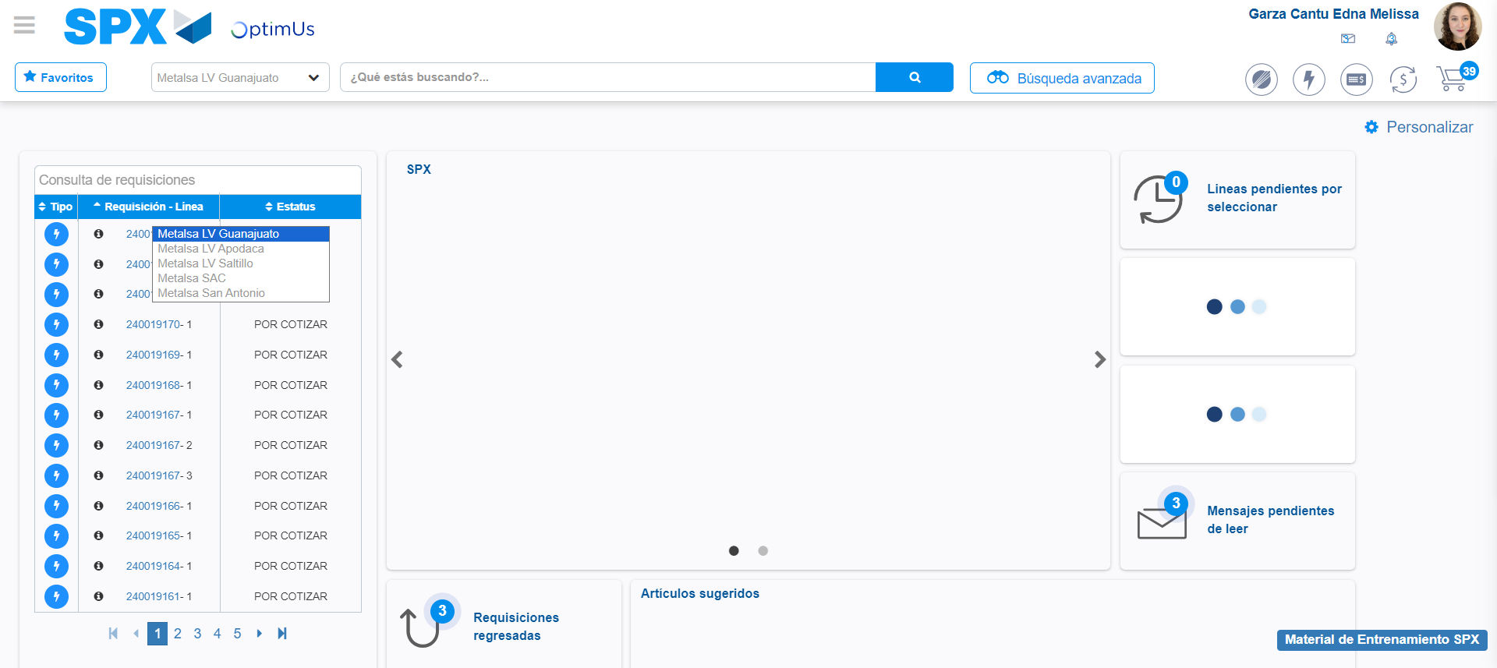Image file-name: QC_Testing-tc005_SPX_Dev5_Validacion_Filtro_Campo_URLPath_Administrador_Menu-may. 15 2024, 01 01 29 p. m.

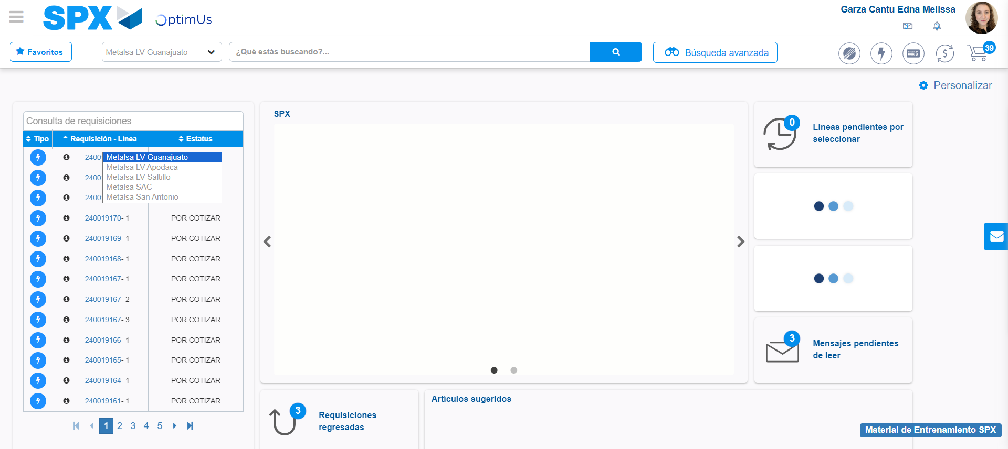Image file-name: QC_Testing-tc005_SPX_Dev5_Validacion_Filtro_Campo_URLPath_Administrador_Menu-may. 15 2024, 01 01 30 p. m.

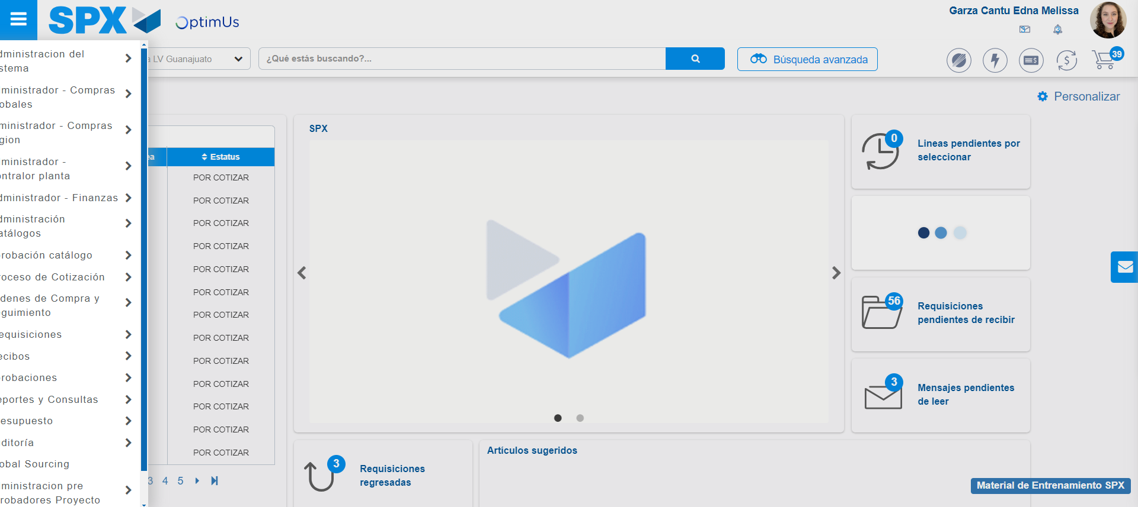Image file-name: QC_Testing-tc005_SPX_Dev5_Validacion_Filtro_Campo_URLPath_Administrador_Menu-may. 15 2024, 01 01 31 p. m.

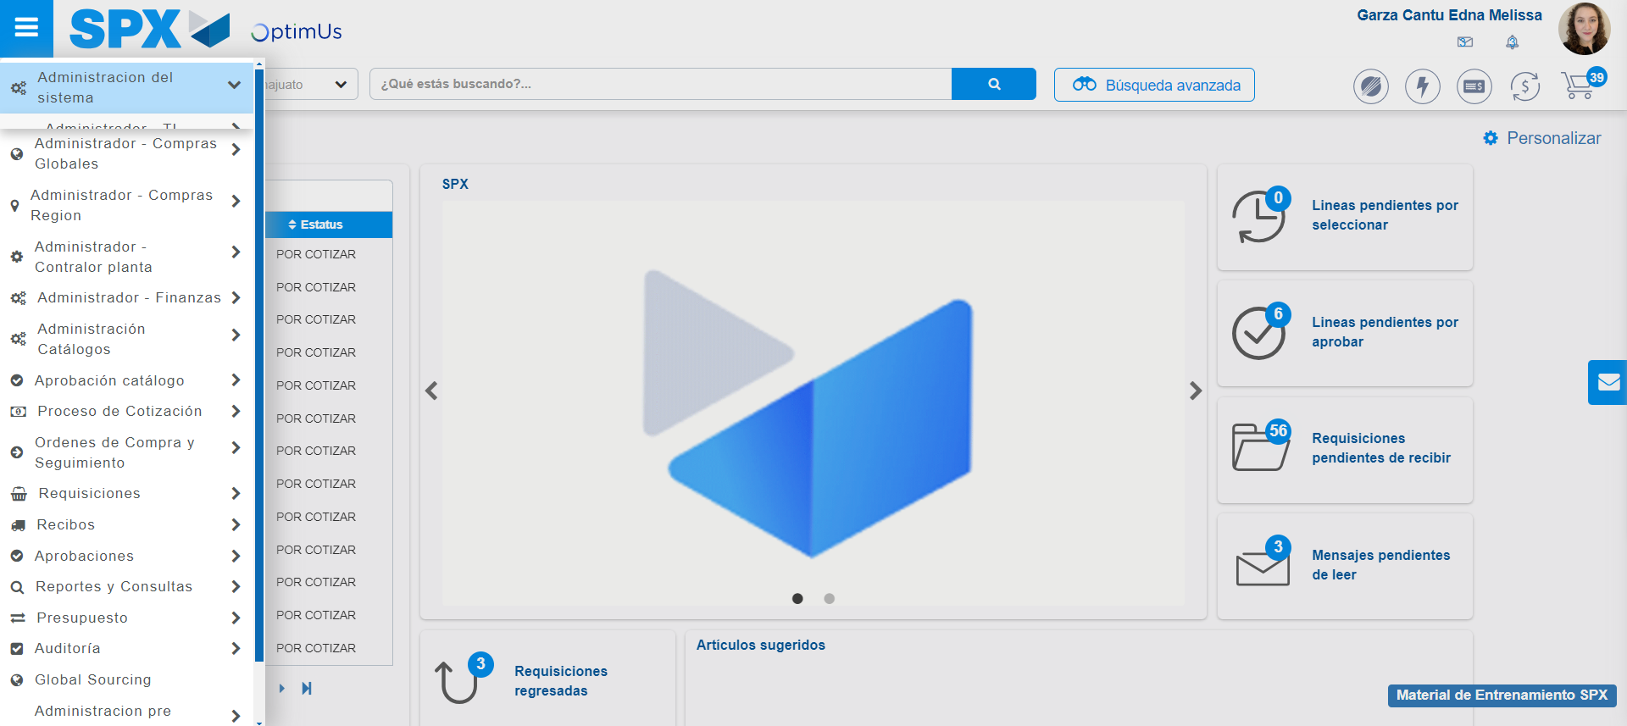Image file-name: QC_Testing-tc005_SPX_Dev5_Validacion_Filtro_Campo_URLPath_Administrador_Menu-may. 15 2024, 01 01 32 p. m.

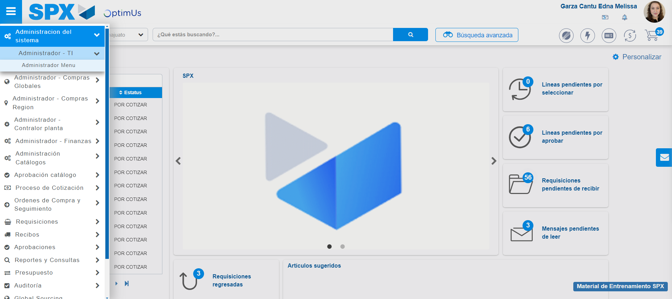Image file-name: QC_Testing-tc005_SPX_Dev5_Validacion_Filtro_Campo_URLPath_Administrador_Menu-may. 15 2024, 01 01 33 p. m.

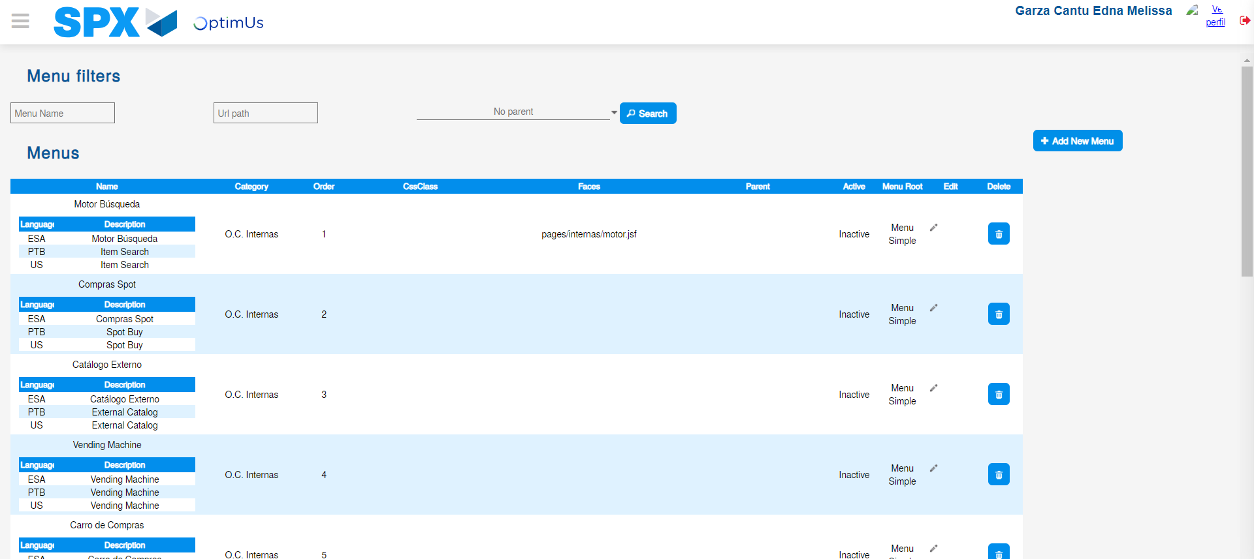Image file-name: QC_Testing-tc005_SPX_Dev5_Validacion_Filtro_Campo_URLPath_Administrador_Menu-may. 15 2024, 01 01 35 p. m.

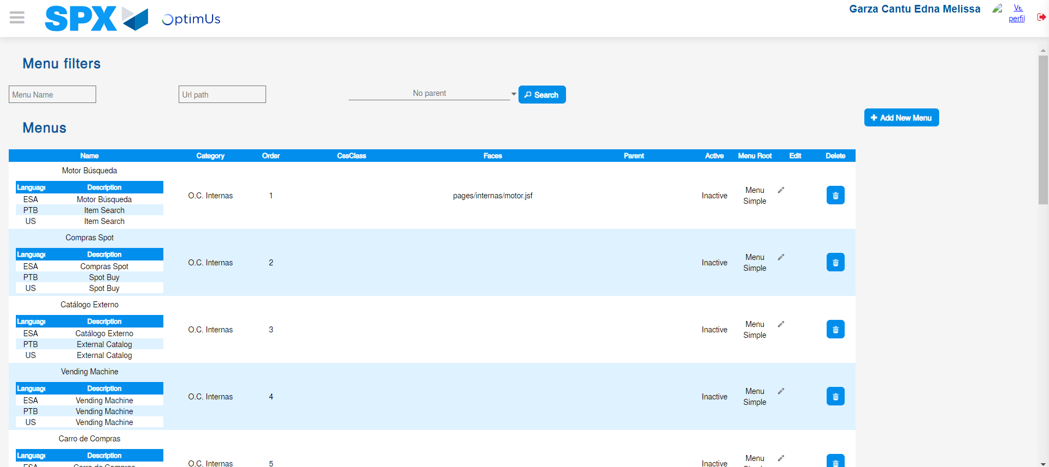Image file-name: QC_Testing-tc005_SPX_Dev5_Validacion_Filtro_Campo_URLPath_Administrador_Menu-may. 15 2024, 01 01 36 p. m.

Step 3 - Perform a search with the URL Path filter: Successful search
Image file-name: QC_Testing-tc005_SPX_Dev5_Validacion_Filtro_Campo_URLPath_Administrador_Menu-may. 15 2024, 01 01 36 p. m.

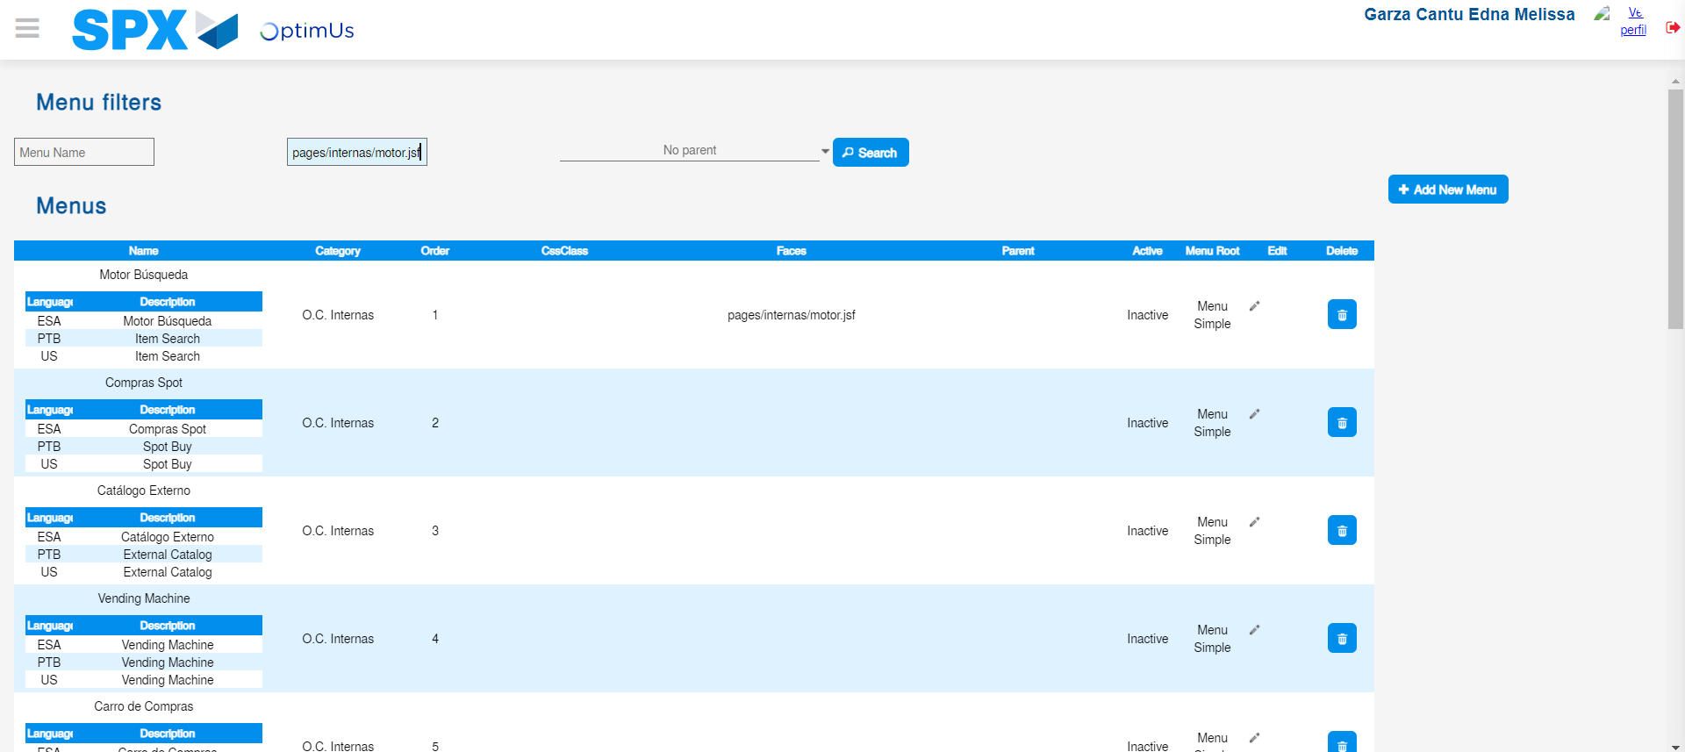Image file-name: QC_Testing-tc005_SPX_Dev5_Validacion_Filtro_Campo_URLPath_Administrador_Menu-may. 15 2024, 01 01 37 p. m.

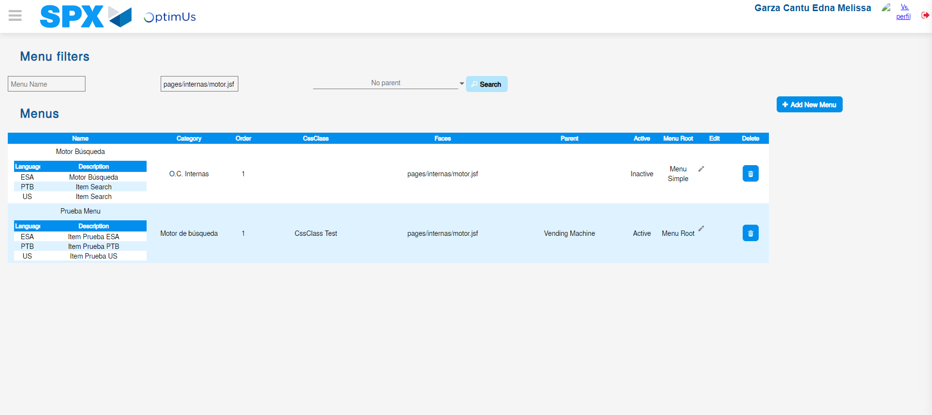Image file-name: QC_Testing-tc005_SPX_Dev5_Validacion_Filtro_Campo_URLPath_Administrador_Menu-may. 15 2024, 01 01 38 p. m.

